Setting up UDP and TCP Ports
- Open Windows Firewall
- Click Advanced Settings
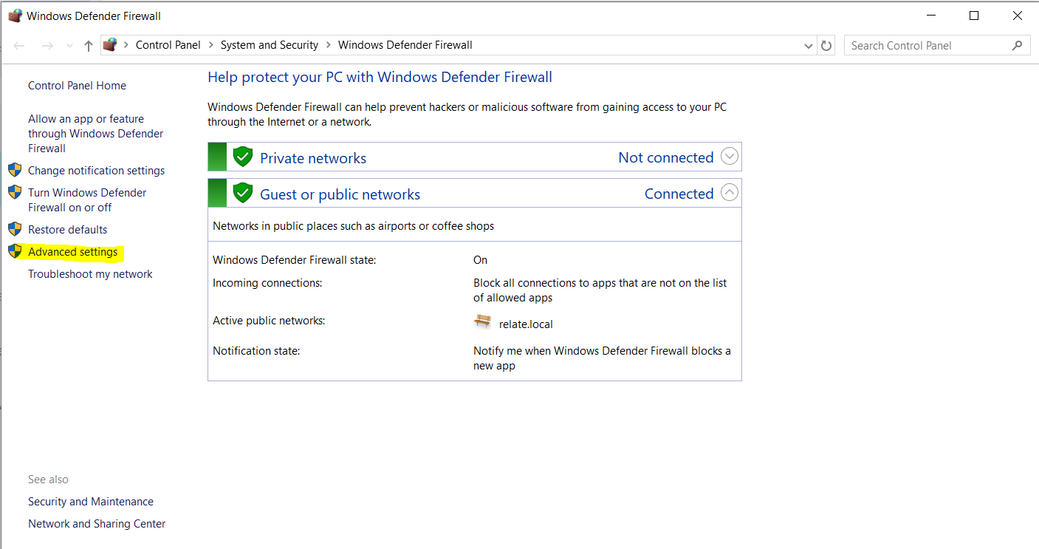
- Click Inbound Rule and then New Rule
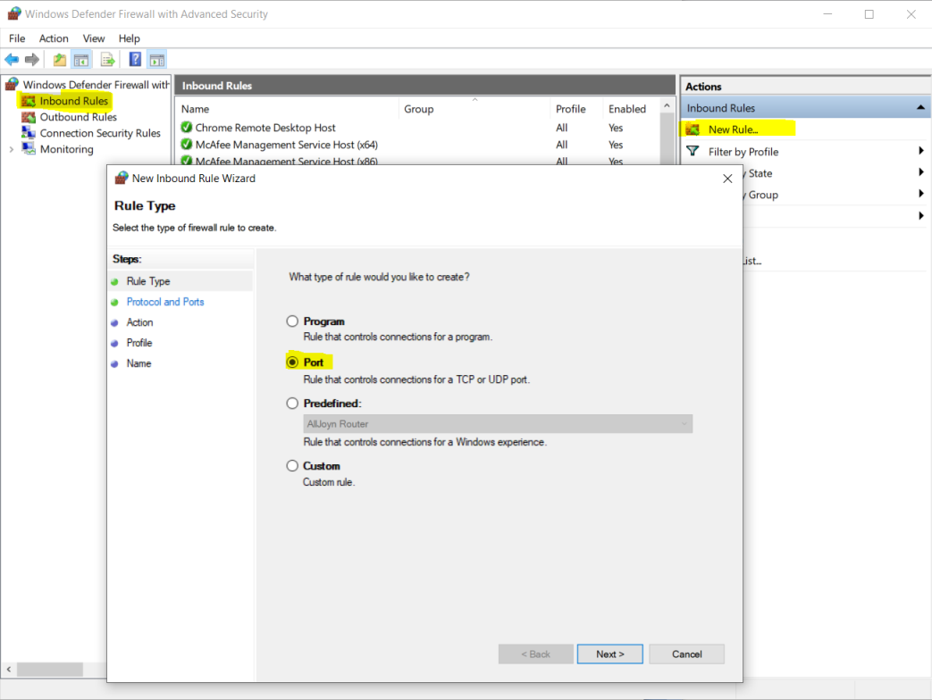
- Select Port and then Next
- Select TCP and enter 1433 in specific local ports and click Next
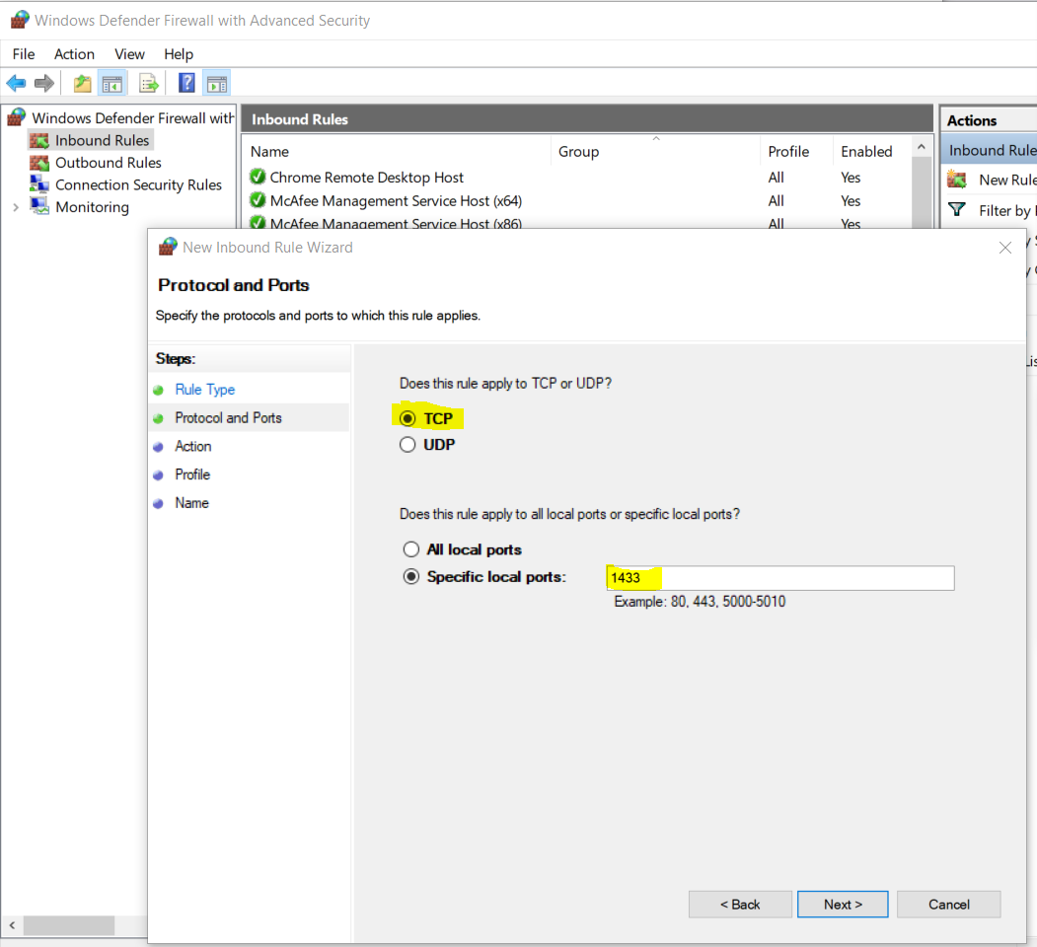
- Click next
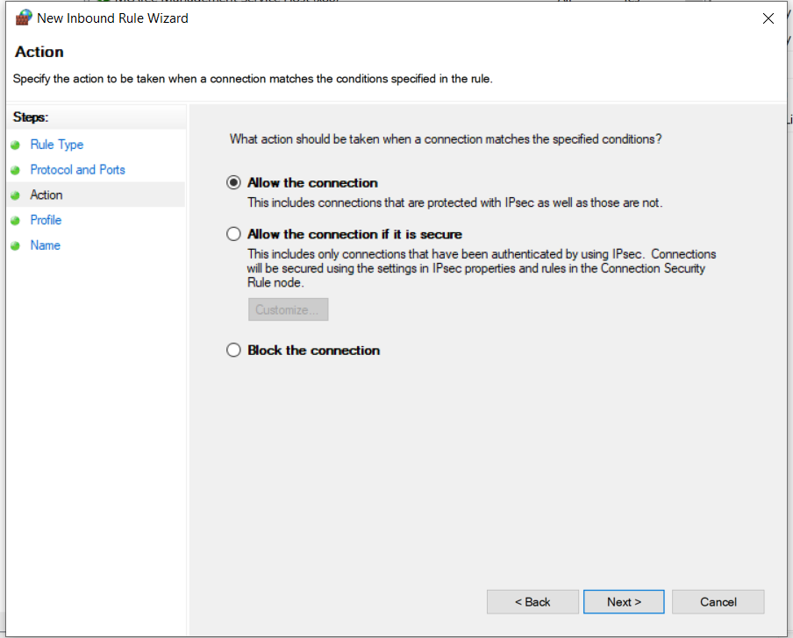
- Click Next again
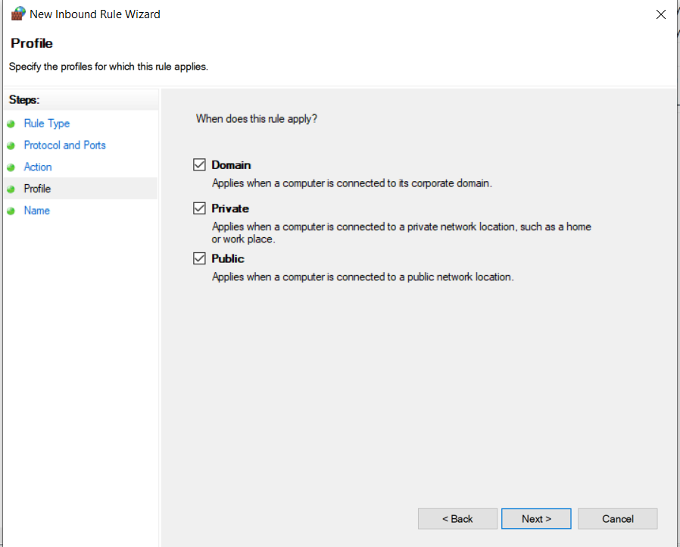
- Enter ‘Relate’ as the name and click finish
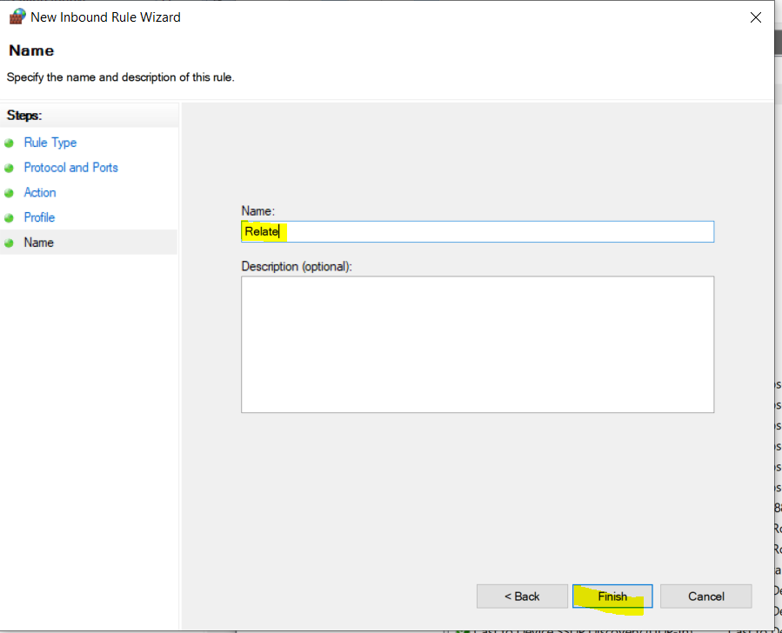
- Repeat the same steps again but choose UDP the next time and enter 1434

